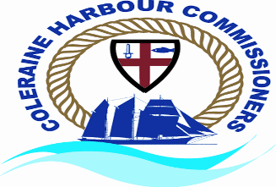

Recruiter – Coleraine Harbour Commissioners

Location – 4 Riversdale Road, Coleraine, Co. Londonderry, Northern Ireland, BT52 1XA.

Position – Senior Pilot

Contract Type - You will be responsible for the safe pilotage of vessels from the point of embarkation to the point of disembarkation within Coleraine Harbour Commissioners competent harbour authority area.

Desirable qualifications of Boatmaster or Yachtmaster or CoC sought.

Paid training will be provided by Coleraine Harbour for your pilotage local knowledge endorsement certificate.

Salary – Please contact the Harbour Office on 028 7034 2012

Closing Date 23rd February 2024 @ 3pm.

Please send information regarding qualifications and experience to harbourcoleraine@gmail.com